**MIT 18.01 Single Variable Calculus, Fall 2007**

This paper is not written by Massachusetts Institute of Technology (as they couldn’t write such sh🌼t). This is simply a short summary of lectures made by me for me.

**Lecture 1. What Is a Derivative**

In school in math classes we faced the function term. Function is a way of converting some value *x* to *y.* Speaking about function description we can characterize *limits* of our function etc. But we can also describe some “*speed*” (this word wasn’t used in lecture, but I heard it in DeepLearningAI course) of function changing at each point. This is a derivative.

Let’s graph some function, and draw a tangent line of some point with coordinates (X0, Y0)

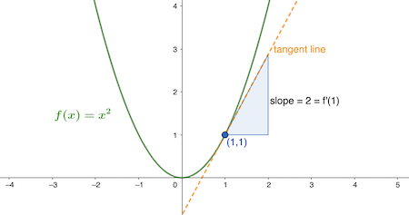

Image stolen from the web (Drawing 1.1)

Now this orange tangent line displays how our function grows.

Derivative can be written in many ways, but here I’ll use Leibniz notation

*dy/dx*

It’s also known as “rise over run”

Or Δy/Δx (same to Δf/Δx)

Actually it’s really important to remember this formula as it makes a great deal.

So. Let’s imagine we have a hyperbola formula 1/x:

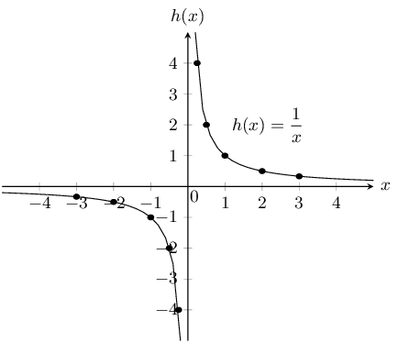

Another stolen image from the web (Drawing 1.2)

Here we can pick any point (X0; Y0)

So our formula turns into:

*ƒ(x0 + Δx) - ƒ(x0) / Δx*

*Simplify it:*

*(1/(x0 + Δx) - 1/x0) / Δx*

*1/Δx (1/(x0 + Δx) - 1/x0)*

*There are few other steps*

*That are pretty obvious*

*(see the scans)*

*And we get:*

*-1 / x0²*

*Simplified hyperbola derivative formula*

So I hope you get the point.

We will not be able to implement it if we don't set Δx to 0.

But why do we set it to 0.

Limits

Limit is some inaccessible value in function

ex. x = x ** 2 if x ≠ 2

But our x may be *infinitely* close to 2

(like 1.999999999999999999999999999999999999999999)

In this case we have a limit on stage:

We get y ≈ 2 ** 2 when our x → 2

Here we also have a limit. We want to calculate derivative at point

(but we can’t use only 1 coordinates)

So we choose some veeeeeery close point to our point (X0; Y0) in the way that:

Δx → 0

So, in order to simplify it we chose Δx = 0

Practice exercises:

1. Simplify derivative of ⨍(x) = x² (Δx = 0)
2. Find area of triangle enclosed by axes and tangent line (y = 1/x)

Check out scans folder to see my notebook notes (photos)

(more information and full calculations there)

________________________________________

This material is free to use, share, and criticize.

This material is not distributed by MIT.

Written by Venchislav for the GitHub community❤.

21.03.2024

_____________

GoodBye!